Web technology and its Applications

**Assignment-02**

**Program-1: Write a JavaScript that calculates the squares and cubes of  the numbers from 0 to 10 and outputs HTML text that displays the  resulting values in an HTML table format.**

**<!DOCTYPE html>**

**<html>**

**<head>**

**<title>Squares and Cubes</title>**

**</head>**

**<body>**

**<table border="1" align="center">**

**<tr>**

**<td>Number</td>**

**<td>SQUARE</td>**

**<td>CUBES</td>**

**</tr>**

**<script type="text/javascript">**

**for(var i=0;i<=10;i++)**

**{**

**document.write("<tr align='center'><td>" + i + "</td><td>" + i*i**

**+"</td><td>" + i*i*i + "</td></tr>")**

**}**

**</script>**

**</table>**

**</body>**

**</html>**

**Tushita S**

**1JT18IS062**

**OUTPUT:**

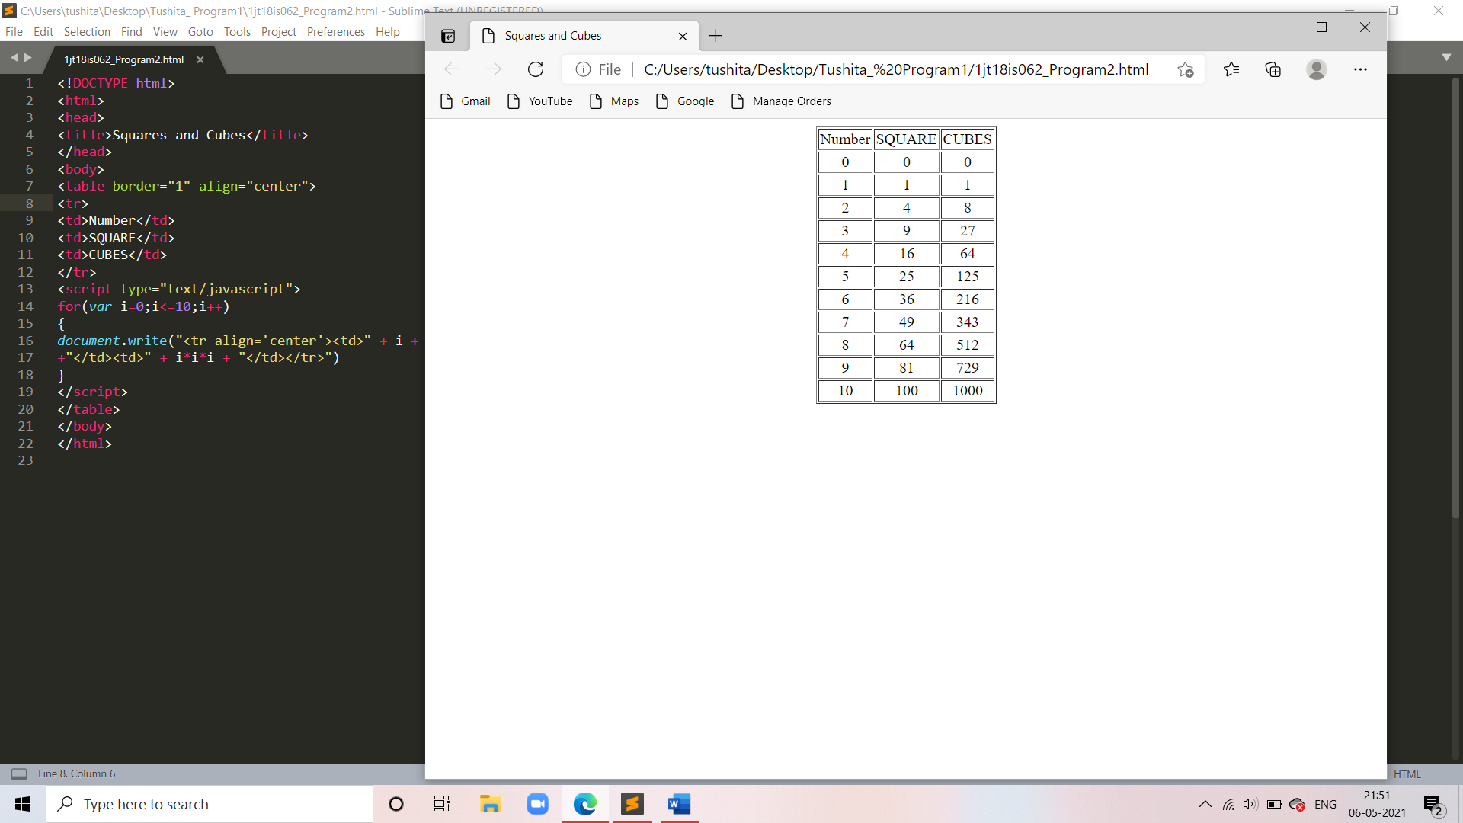

**CHALLENGE**

<!DOCTYPE html>

<html>

<head>

<style>

tr,td{

border: solid black;

width: 33%;

text-align: center;

**Tushita S**

**1JT18IS062**

background-color: orange;

font-size: 25px;

}

table{ margin:auto;

border-collapse: collapse;

}

h3{

font-size: 30px;

font-family: Times New Roman;

color:;

}

@keyframes blink{

65%{

opacity: 0;

}

80%{

opacity: 1;

}

}

h1{

text-align: center;

padding: 50px;

font-family:Monaco;

color: red;

font-size: 30px;

animation: blink 3s linear infinite;

}

**Tushita S**

**1JT18IS062**

</style>

</head>

<body>

<table>

<tr>

<th colspan="3"><h3>Numbers from 10 to 100 with their squares and cubes</h3></th>

</tr>

<tr>

<td> Numbers </td>

<td> Squares </td>

<td> Cubes </td>

</tr>

<script>

for(var i=100; i<=1000; i=i+100)

{

document.write( "<tr><td>" + i + "</td><td>" + i*i + "</td><td>" + i*i*i

+ "</td></tr>" )

}

</script>

</table>

<h1> Assignment-2 **Challenge Completed!** </h1>

</body>

</html>

**Tushita S**

**1JT18IS062**

**Output:**

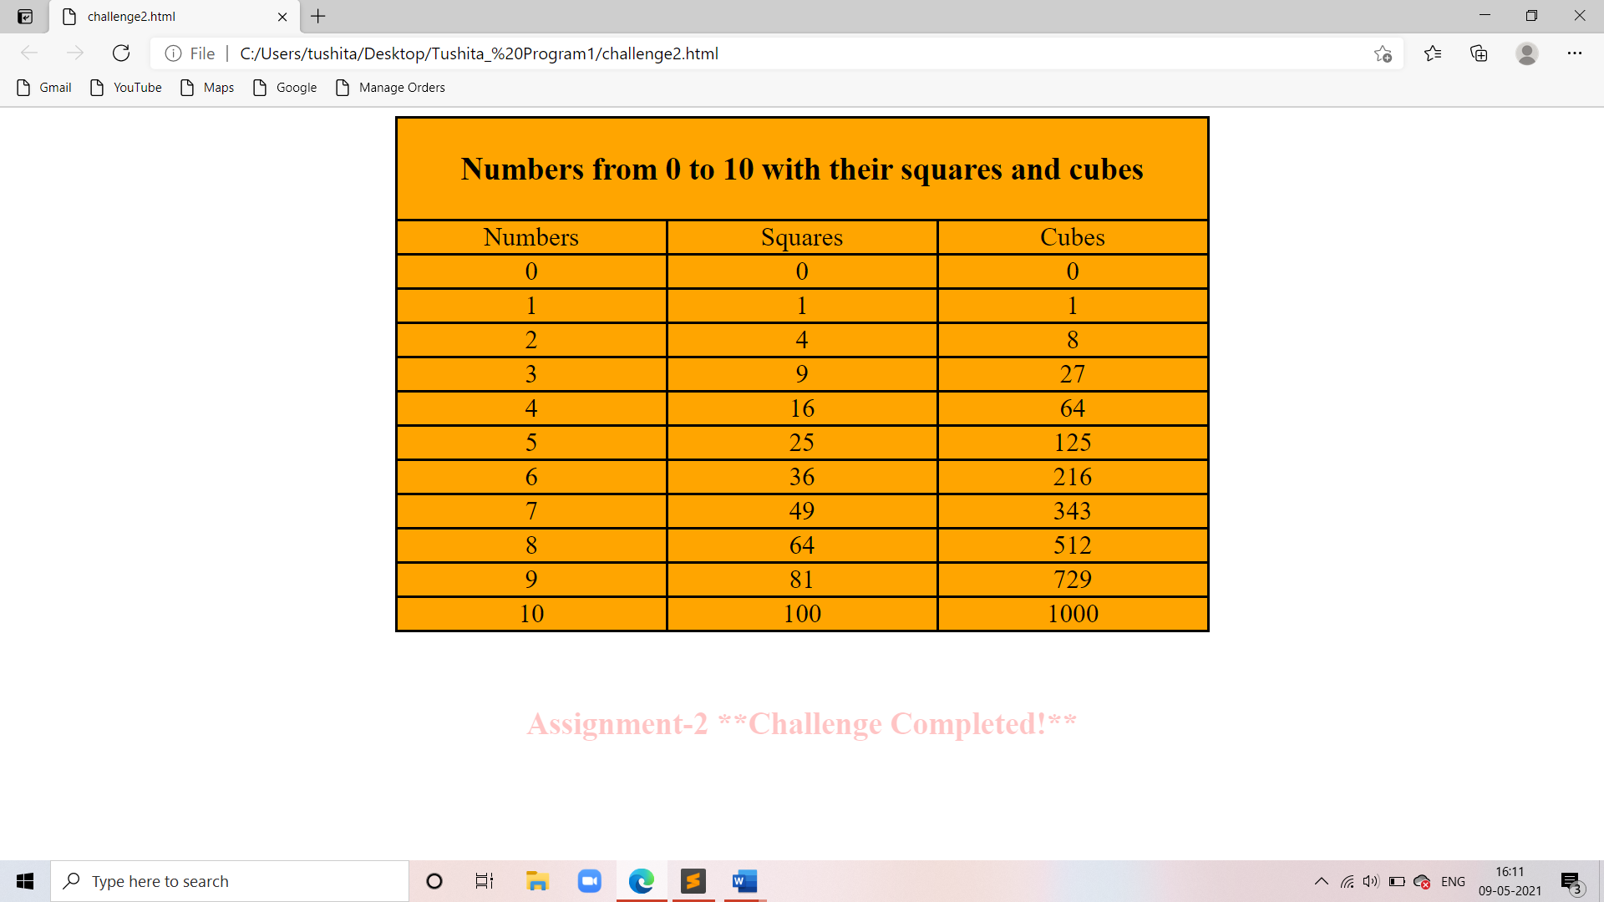

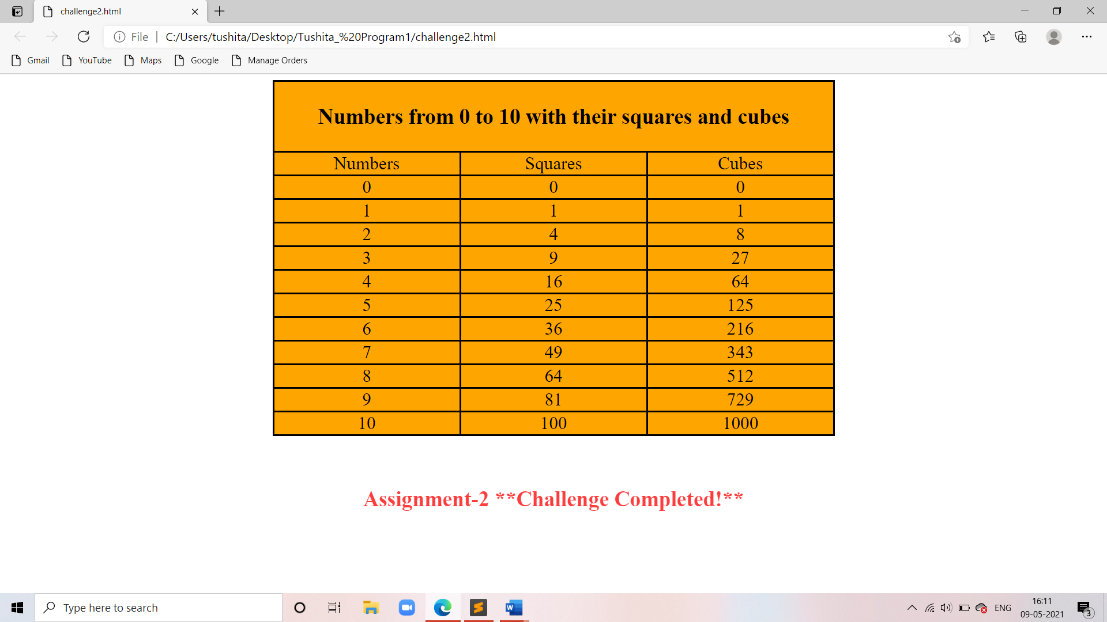

**Tushita S**

**1JT18IS062**

|  |  |  |
| --- | --- | --- |
| **Test no.** | **Input parameters** | **Output Image** |
| 1. | i=0 to 10,  increment of i+1 |  |
| 2. | i=10 to 100,  increment of i+10 |  |

|  |  |  |
| --- | --- | --- |
| 3. | i=100 to 1000,  increment of i+100 |  |

**Tushita S**

**1JT18IS062**

THE END